**Minjung Misul (‘The People’s Art’)**

*Minjung misul* (‘The People’s Art’) was the most prominent South Korean art movement of the 1980s, occurring during the epoch of a three-decade pro-democracy movement. In the political ideology and praxis of the dissident intellectuals and activists, whose historical and political consciousness had been shaped by the May 18, 1980 Gwangju Uprising, the notion of *minjung* was central. The *minjung* were defined as historically oppressed people who could rise up against oppression. Minjung misul was conceived during this politically transitional period. The emergence of minjung misul came late to the minjung cultural movement, almost two decades after literature and performance, owing mostly to pervasive artistic modernism and conservatism in Korea’s art world. A decade after the short-lived ‘Reality Group’ (1969), the art collective ‘Reality and Utterance’ (1979–90) joined to criticise institutional art practices (i.e., *tansaekhwa*). Aligning with earlier dissident critics *minjung* artists and critics assessed the development of Korean modernism as formalist and derivative, and as alienated from socio-political realities. Members of Reality and Utterance and Yimsulnyeon (1982–87) attempted to communicate these realities through Social realism and Photorealism, respectively. In Gwangju, a traditional periphery of the art centre, the Gwangju Freedom Artists Association (1979–85) aimed at creating art with the ‘power of testimony and speech,’ with a more praxis-oriented approach.

The art collective ‘Dureong’ (a ridge between fields; 1982–?), whose members were involved in the national culture movement, created “art of life” based on the living aesthetics of traditional agrarian communities, including folk art. Away from conventional artistic expressions and the closed circuit of art institutions, their members endeavoured to bring art into the everyday lives of people (e.g., rubber print and communal art projects) with the goal of democratizing art.

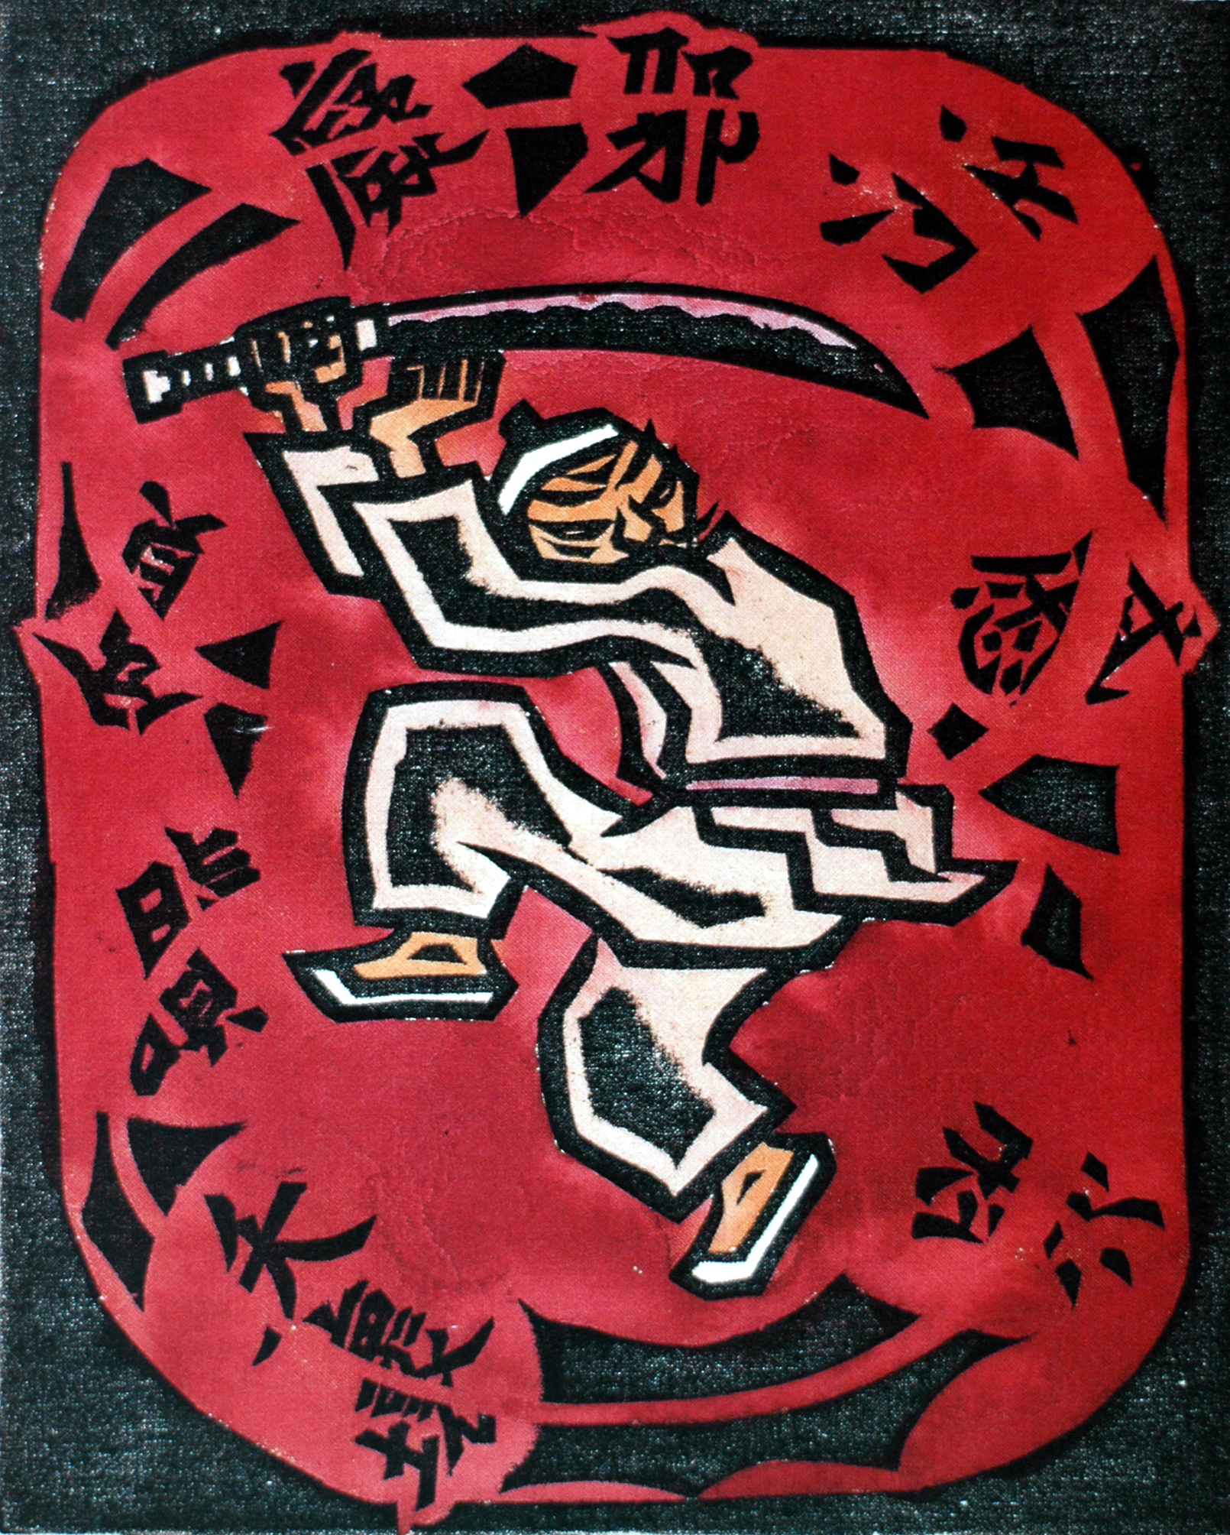

Oh Yun, *The Song of the Sword*, 1985, Woodblock, Cotton Cloth, Color, 12.7x10 inches. Copyright: contact Bae Hyeonsu, Leeum (Samsung Museum of Art).

The Seoul Art Community organized the *1985, Korean Art, the 20s “Power*”’ exhibition (July 13–22, Arab Art Museum) with the aim of the “establishment of the people’s and national art” and the “democratization of the art world.” In response, the police closed the exhibition, destroyed and confiscated some works, and arrested several artists. It was the time when their socially engaged art was known as minjung misul to the public, termed by the cultural minister Yi Won’gong in a pejorative sense. Against this backdrop, *minjung* artists and critics created the National Artists Association in 1985. Groups of *minjung* artists expanded the sphere of their movement, actively reaching out to people and serving the pro-democracy movement.

The most dramatic events of post-Gwangju Korean politics culminated in the June 10, 1987 popular uprisings nationwide and in the 1987 July–September Great Workers’ Struggle. Choe Byeongsu’s banner painting *Bring Hanyeol Back to Life*, as part of the June 10 popular uprisings, is an excellent example of *minjung misul* as tactical media. From the early 1990s, some *minjung* artists moved their art to gallery spaces and experimented with new media and subjects. In 1994, the large-scale exhibition *Minjung Misul 15 Years, 1980–1994*,was held atthe government-sponsored National Museum of Contemporary Art (now, National Museum of Modern and Contemporary Art), under the first civilian government, led by President Kim Young Sam (1993–98). Although it was a ground-breaking event, this exhibition was evaluated as the movement’s institutionalisation and even its end by some critics.

**References and Further Reading**

---- (1994) *Minjung misul 15 nyeon: 1980-1994* [Minjung misul 15 years: 1980-1994], edited by the National Museum of Contemporary Art, Seoul: Salm gwa kkum, 1994.

Kim Yunsu, (1988) *Han’guk hyeondae misul ui banseong* [Critical reflection on Contemporary Korean Art], edited by Minjok misul heop’uihoe, Seoul: Han’gyeore.

Seong Wan’gyeong, (1999) *Minjung misul, modeonism, sigak munhwa: saeroun hyeondaereul wihan seongchal—Seong Wan’gyeong’s misul bepyeong* [Minjung Misul, Modernism and Visual Culture: self-examination for new contemporary], Seoul: Yeolhwadang.